**ONLINE BLOOD DONATION APPLICATION UI**

**INTERDISCIPLINARY PROJECT**

Submitted in partial fulfillment of the requirements for the award of Bachelor of Engineering degree in Computer Science and Engineering

By

**INFANT JUDE HARRISON D**

**Reg. No–42110467**



**DEPARTMENT OF COMPUTER SCIENCE AND ENGINEERING**

# SCHOOL OF COMPUTING

SATHYABAMA

## INSTITUTE OF SCIENCE AND TECHNOLOGY

## (DEEMED TO BE UNIVERSITY)

**CATEGORY - 1 UNIVERSITY BY UGC**

**Accredited with Grade “A++” by NAAC | Approved by AICTE**

**JEPPIAAR NAGAR, RAJIV GANDHI SALAI, CHENNAI - 600119**

APRIL - 2025



**DEPARTMENT OF COMPUTER SCIENCE AND ENGINEERING**

**BONAFIDE CERTIFICATE**

This is to certify that this Professional Training-1 Report is the bonafide work of **INFANT JUDE HARRISON D (42110467)** who carried out the project entitled **“ONLINE BLOOD DONATION APPLICATION UI”** under my supervision from January 2025 to April 2025.

**Internal Guide**

**Dr. A. PRAVIN, M.E., Ph.D.,**

**Head of the Department**

**Dr. L. LAKSHMANAN, M.E., Ph.D.,**

**Submitted for Viva voce Examination held on __________________**

**Internal Examiner External Examiner**

**DECLARATION**

I, **INFANT JUDE HARRISON D** (Reg. No- 42110467), hereby declare that the Professional Training-2 Report entitled “**ONLINE BLOOD DONATION APPLICATION UI**” done by me under the guidance of **Dr. A. PRAVIN, M.E., Ph.D**., is submitted in partial fulfillment of the requirements for the award of Bachelor of Engineering degree in Computer Science and Engineering.

**DATE:**

**PLACE: Chennai**

**SIGNATURE OF THE CANDIDATE**

**ACKNOWLEDGEMENT**

I am pleased to acknowledge my sincere thanks to **BOARD OF MANAGEMENT** of **Sathyabama Institute of Science and Technology** for their kind encouragement in doing this project and for completing it successfully. I am grateful to them.

I convey my thanks to **Dr. T. SASIKALA, M.E., Ph. D.,** Dean, School of Computing, and **Dr. L. LAKSHMANAN, M.E., Ph.D.,** Head of the Department of Computer Science and Engineering for providing me with necessary support and details at the right time during the progressive reviews.

I would like to express my sincere and deep sense of gratitude to my Project Guide **Dr. A. PRAVIN, M.E., Ph.D.,** for her valuable guidance, suggestions, and constant encouragement paved the way for the successful completion of my project work.

I wish to express my thanks to all Teaching and Non-teaching staff members of the Department of Computer Science and Engineering who were helpful in many ways for the completion of the project.

# TRAINING CERTIFICATE



**ABSTRACT**

LifeDrop is a mobile application aimed at simplifying and promoting blood donation through a digital platform that connects donors with individuals or hospitals in need of blood. The app allows users to register as donors, check eligibility, schedule donation appointments, and track their donation history. It also enables patients or healthcare providers to request blood by submitting relevant information and medical documents. Designed with a focus on usability, accessibility, and social impact, the interface offers a clean and intuitive user experience, guiding both new and returning users through the donation or request process. Key features include onboarding screens, donation guidelines, a donor tracker, emergency request forms, and user profile management. LifeDrop also educates users who are new to blood donation, making the process less intimidating and more transparent. This UI/UX project demonstrates how thoughtful design and user-centric functionality can create a meaningful digital solution to address an ongoing public health need.

**TABLE OF CONTENTS**

|  |  |  |
| --- | --- | --- |
| **CHAPTER NO.** | **TITLE** | **PAGE NO.** |
|  | **ABSTRACT** | vi |
|  | **TABLE OF CONTENTS** | vii |
|  | **LIST OF FIGURES** | viii |
| **1.** | **INTRODUCTION** | 1 |
|  | 1.1 OVERVIEW | 2 |
| **2.** | **LITERATURE SURVEY** | 3 |
|  | 2.1 CHALLENGES IN EXISTING SYSTEM | 4 |
| **3.** | **METHOD AND IMPLEMENTATION** | 5 |
|  | 3.1 REQUIREMENT ANALYSIS | 5 |
|  | 3.2 SYSTEM ARCHITECTURE | 7 |
|  | 3.3 IMPLEMENTATION | 11 |
| 4. | **RESULTS AND DISCUSSION** | 14 |
| 5. | **CONCLUSION** | 16 |
|  | **REFERENCES** | 17 |
|  | **APPENDIX** | 18 |
|  | A.SCREENSHOTS | 18 |
|  | B. SOURCE CODE | 23 |

|  |  |  |
| --- | --- | --- |
|  | **LIST OF FIGURES** |  |
| **FIGURE NO.** | **FIGURE NAME** | **PAGE NO.** |
| 3.1 | FILE STRUCTURE | 9 |
| 3.2 | WORK FLOW | 10 |
| 4.1 | HOME SCREEN | 14 |
| 4.2 | REQUEST BLOOD SCREEN | 15 |
| 4.3 | LOGIN SCREEN | 16 |
| 4.4 | USER PROFILE SCREEN | 17 |

# CHAPTER 1

# INTRODUCTION

The **Online Blood Donation Application UI Project** is developed to create an accessible, user-friendly platform that simplifies the process of donating and requesting blood through a mobile application. With the growing need for efficient healthcare support and the increasing use of digital services, there is a significant demand for streamlined systems that connect blood donors with recipients quickly and reliably. This project addresses that need by offering a centralized digital solution that encourages voluntary blood donation while ensuring timely access to blood for patients and hospitals.

Traditionally, blood donation and requests were managed manually or through word-of-mouth and hospital networks, which often led to delays and inefficiencies. This system overcomes those challenges by providing 24/7 access to donation and request services, donor tracking, and educational resources for first-time donors. It serves both donors, who can easily check eligibility and schedule donations, and recipients, who can submit urgent blood requests with verified documentation.

The project emphasizes an intuitive user experience with features like onboarding guidance, appointment booking, request forms, donor history, and donation countdown tracking. It also includes a self-check process to promote safe donations and a dedicated space for guidelines to raise awareness and reduce fear or confusion among new users.

By digitizing and simplifying the blood donation process, this project contributes to improving public health outcomes and building a stronger, more connected network of voluntary donors and recipients.

.

## 1.1 OVERVIEW

The **Online Blood Donation Application UI – LifeDrop** is a mobile-first UI/UX design project developed using Figma, aimed at creating an intuitive and engaging platform for blood donors and recipients. This conceptual application is designed to visualize how users could interact with a digital blood donation ecosystem that promotes awareness, simplifies the donation process, and supports individuals in need of blood. LifeDrop caters to two main user groups: individuals willing to donate blood and those seeking to request it in times of emergency or medical need.

Key components of the system include:

* **User Interface:** A clean and accessible interface designed to guide users through onboarding, donor registration, blood requests, and profile management. The layout prioritizes ease of navigation and emotional connection through meaningful visuals and messages.
* **Donor and Request Flow:** Dedicated flows allow users to become a donor by checking eligibility and filling out donation details, or to request blood by submitting necessary information such as patient name, location, and urgency.
* **Donation Tracker:** A visual countdown feature informs users when they are next eligible to donate, promoting regular and safe blood donations.
* **Guidelines and Support:** Informational sections provide safety tips, eligibility criteria, and reassurance for first-time donors, making the experience more inclusive and educational.
* **Figma-based Design:** As a UI/UX prototype, the system focuses entirely on the visual and interactive elements without the integration of real-time data, databases, or backend logic.

# CHAPTER 2

# LITERATURE SURVEY

A literature survey on online blood donation systems involves reviewing past research studies, case studies, articles, and relevant digital health literature to understand the evolution, challenges, and user experience considerations in this space. This survey provides insights into the design principles, technological advancements, and the role of digital platforms in improving blood donation awareness and accessibility.

A structured list of research papers, healthcare reports, and academic studies is typically included to support the findings and ensure the survey is based on credible, authoritative sources. These may include journals on healthcare technology, user-centred design, and mobile health (mHealth) systems.

This literature survey presents a clear overview of the development of digital blood donation platforms, current trends, challenges, and the design considerations shaping their future.

• **Traditional Blood Donation**

1. Blood donation traditionally depended on hospital visits, physical camps, and word- of-mouth communication. This often resulted in delays, limited reach, and lack of information for both donors and recipients.

• **Early Digital Efforts**

1. Initial platforms focused on listing blood donors or requests through basic websites and forums. However, these lacked proper structure, security, and usability, making them less reliable in emergencies.

• **Modern App-Based Platforms**

1. Recent studies such as Sharma et al. (2018) and Rao & Iyer (2021) highlight how app-based solutions have improved accessibility with better UI/UX design, location-based services, and user engagement through reminders and updates.

• **User Experience in Health Apps**

1. Research like Kumar & Patel (2020) emphasizes the importance of intuitive design, emotional connection, and educational support in health-related apps. These elements help in reducing anxiety and promoting informed decisions among users.

• **Mobile vs. Web-Based Platforms**

1. Mobile applications are favoured for their ease of access, portability, and ability to provide real-time interaction. While web platforms offer broader device compatibility, mobile apps are often more effective for personal engagement and behaviour-driven goals like voluntary donation.

**2.1 CHALLENGES IN EXISTING SYSTEM**

The existing blood donation systems, while helpful in emergencies, often lack structure, accessibility, and user engagement. Most rely on manual communication, hospital visits, or basic online listings, which can result in delays and an inconsistent user experience. Donors are not always provided with proper guidance, and recipients often struggle to find verified donors quickly during urgent situations. Many existing platforms also lack intuitive onboarding processes, making it difficult for users to understand how to register as a donor or request blood. Without clear visual cues, helpful prompts, or progress indicators, users may abandon the process midway due to confusion or frustration. This results in reduced engagement and missed opportunities for potential donors.

Although some digital platforms have emerged, they tend to offer limited features, fragmented interfaces, and poor navigation. Many of these systems do not include essential elements like donation history tracking, eligibility checks, or reminders for repeat donations. This lack of functionality and emotional design makes the process less approachable, especially for first-time donors.

Additionally, there is little to no personalization or support for users during the donation journey. Mobile-first usability and engaging user experiences are often missing, reducing the platform's effectiveness. Overall, while the idea of digital blood donation systems is growing, existing solutions fall short in terms of user-centric design, accessibility, and usability.

# CHAPTER 3

# METHOD AND IMPLEMENTATION

# 3.1 REQUIREMENT ANALYSIS

**3.1.1 SOFTWARE ANALYSIS**

* **Design Platform**
* Figma – for UI/UX design and interactive prototyping.
* **Operating System**
  + Compatible on any OS with browser access: Windows, macOS, Linux (for desktop users).
  + Mobile compatibility: Android and iOS browsers or apps (visualized in design).
* **Browser Requirements**
  + Chrome, Firefox, Safari, Edge – latest versions recommended for optimal Figma preview.
* **Design Components**
* **UI Elements:** Buttons, input fields, icons, cards, toggles, modals, and sliders.
* **Layout Grids:** Used for maintaining design consistency across screens.
* **Wireframing & Prototyping Tools**
* Low-fidelity wireframes for structure.
* High-fidelity mockups for detailed screens.
* Interactive prototyping to simulate app flow.
* **Typography & Color Scheme**
  + Google Fonts used for readability and accessibility.
  + Color palette designed for clarity, urgency, and trust – includes red tones, white backgrounds, and dark text for contrast.
* **Plugins Used in Figma**
* Iconify (for icons), Unsplash (for placeholder images), Content Reel (for sample data).
* **Version Control**
  + Figma’s built-in version history for tracking design progress.
* **Team Collaboration**
  + Shared Figma project with commenting features for team feedback and design iteration.
* **Export Options**
  + Screens exported as PNG, JPG, or PDF for presentation and documentation.
  + Developer handoff available via Figma Inspect for future implementation.

**3.1.2 HARDWARE ANALYSIS**

* **Design Workstation**
  + **Processor**: Dual-core CPU or higher.
  + **RAM**: Minimum 4GB (8GB+ recommended for smooth use with Figma).
  + **Storage**: SSD with a minimum of 10GB for local files and browser cache.
  + **Display**: Minimum resolution of 1366x768; 1920x1080 or higher recommended.
* **Internet Connection**
  + Stable broadband connection required for cloud-based Figma access.
  + Recommended speed: 5 Mbps or higher for smooth collaboration and preview.
* **Mobile Device** (for testing visuals)
  + Android 8.0+ or iOS 12+ compatible smartphones for mobile UI preview via Figma Mirror or web browser.

## 3.2 SYSTEM ARCHITECTURE

The LifeDrop Online Blood Donation System follows a conceptual 3-tier architecture, modelled entirely within Figma. It includes a Presentation Layer (user interface), a Logic Flow Layer (user navigation and interactions), and a Data Representation Layer (visual placeholders for donor and recipient information). Though it lacks actual backend or database integration, the architecture is designed to simulate a real-world application, supporting a clear and scalable user experience. This modular structure ensures ease of understanding, smooth navigation, and sets a foundation for future development.

**3.2.1 PRESENTATION LAYER (Client Side)**

The Presentation Layer represents the front-end of the LifeDrop system, created using Figma as a high-fidelity UI/UX design. This layer showcases the visual structure, interface layout, and user interaction flow for donors, recipients, and administrators. It includes navigation screens, forms for registration, login, and blood request, as well as interactive elements like buttons, cards, and dashboards.

Since it is a design prototype, this layer simulates responsiveness and interactivity through linked frames and design components. The layout supports accessibility across devices and is optimized for usability, clarity, and simplicity.

**Functionality simulated in this layer includes**

* **Donor Registration and Login Screens:** Visual design for secure user onboarding.
* **Blood Request Form:** Designed interface for users to request blood units based on type and urgency.
* **Dashboard Mock-ups:** Includes donor lists, request status, and availability.
* **Admin Controls:** Interface to manage requests, users, and overall system monitoring.

**3.2.2 BUSINESS LOGIC LAYER (Application Server)**

The Business Logic Layer is conceptually represented in the LifeDrop Figma model through structured user flows and screen transitions. Though it is not functionally implemented, this layer is designed to simulate how the system would handle user actions, apply rules, and process interactions in a real-world scenario.

Each screen is interconnected in a way that reflects logical workflows—such as navigating from login to dashboard, or processing a blood request form. The interactions illustrate how data might be validated, requests approved or denied, and roles managed (donor, recipient, admin).

This simulated logic forms the foundation for future development, where actual backend technologies can be integrated.

**3.2.3 DATA LAYER (Database)**

As LifeDrop is a UI/UX prototype, it does not include a working database. However, the data layer is visually represented through static content blocks and placeholders that depict how user information, donor availability, and request records would appear and be organized.

The screens show how data would be displayed and updated, including user lists, blood inventory, and status updates. These visual elements help in understanding how real-time information would flow and be accessed in a functioning application.

* + 1. **FILE STRUCTURE**

As a Figma-based design project, the file structure is managed within the design tool itself. The LifeDrop file is organized into separate pages and frames for different user roles (Donor, Recipient, Admin). Each screen is grouped and labelled clearly for easy navigation and iteration. Components such as buttons, headers, and forms are reused through Figma's component system for consistency and efficiency.

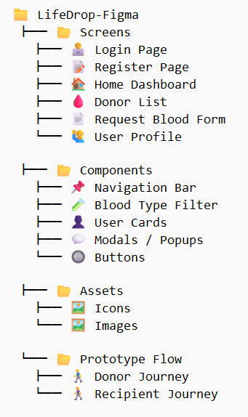

Fig 3.1 File Structure

The Figure 3.1 explains the file structure of the **LifeDrop Blood Donation System**, highlighting the separation between frontend and backend components. It showcases organized directories for screens, components, and services used in the React-based frontend. The backend includes models, routes, and configuration files powered by Node.js and MongoDB. This structure ensures modularity, scalability, and efficient project management.

**3.2.5 WORKFLOW**

The Figure 3.2 explains the **user workflow of the LifeDrop Blood Donation System**, starting from user authentication through registration or login. After accessing the home screen, users can explore options such as donating, requesting blood, viewing guidelines, or tracking their donation/request history. The flow ensures intuitive navigation and access to all core features.

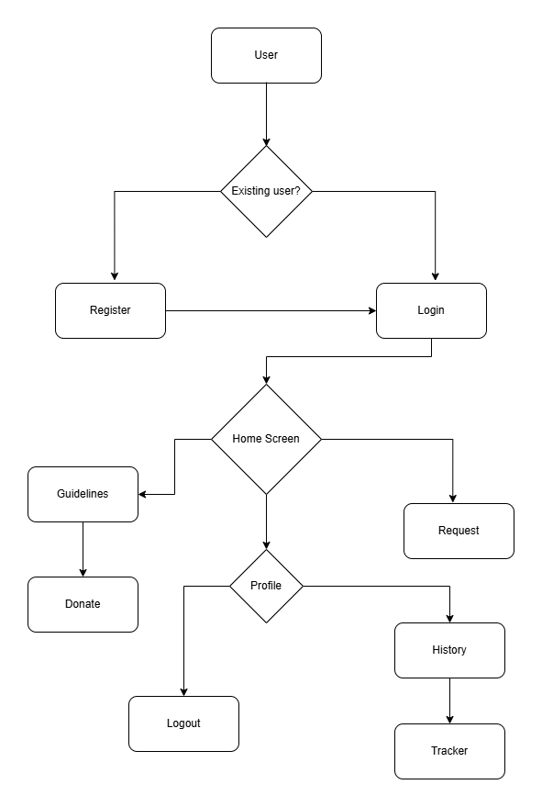

Fig 3.2 Work Flow

**3.3 IMPLEMENTATION**

The LifeDrop Blood Donation System is currently designed as a high-fidelity prototype using Figma, focusing on an intuitive user interface and user-centric experience. The project follows key UI/UX design principles to ensure smooth navigation, clarity, and accessibility for users across various roles such as donors and recipients. This prototype lays the groundwork for future development phases.

**3.3.1 SYSTEM DESIGN**

The system design emphasizes a seamless flow and clear visual hierarchy for all interactions. Key design components include:

* **User Interface**: Designed in Figma with responsive layouts, it includes dedicated screens for registration, login, donation requests, donor tracking, and profile management. Icons and visuals enhance usability and user engagement.
* **User Roles**: The prototype supports both donors and recipients with distinct flows tailored to their needs, ensuring a personalized experience throughout.
* **Navigation Flow:** From home to donation guidelines, request creation, history, and the tracker, the interface maintains consistent navigation logic and user feedback elements (e.g., success messages, spinners).
* **User- Centred Prototyping:** The system design follows user-centered principles, with each screen and flow created based on the needs of donors and recipients. Special attention was given to ease of navigation, accessibility, and minimal input steps to encourage engagement and reduce drop-off.

**3.3.2 CORE FEATURES AND FUNCTIONALITIES**

The Figma prototype demonstrates the following main features:

* **User Registration and Authentication:** Separate screens allow new users to register and existing users to log in with clear input validation and helpful prompts.
* **Donation Request Workflow:** Recipients can create donation requests, which are visually organized and designed to be easy to track and manage.
* **Donor Tracker:** A dedicated screen allows users to track their donation status, including history, progress, and availability for future donations.
* **Guidelines Integration:** Users are guided with donation eligibility criteria and safety tips via the Guidelines screen before initiating a donation.
* **Profile Management:** Users can view and update their profile details, view donation history, and manage their donation preferences.
* **Blood Donation Tracker:** A visual tracker is included in the prototype to help donors monitor their last donation date, eligibility for the next donation, and donation history. This feature aims to encourage repeat donations and boost engagement over time.

**3.3.3 TOOLS & TECHNOLOGIES USED**

The implementation of the system involves a stack of technologies suited to building secure, scalable, and efficient blood donation system. The technologies include:

* **Design Tool:** Figma – for wireframing, prototyping, and collaborative design.
* **Icons & Assets:** SVG icons and image assets integrated into the prototype for visual clarity.
* **Design System:** Consistent use of components, colour palette, typography, and spacing based on UI design standards.

**3.3.4 SYSTEM TESTING**

As part of the design phase, the prototype underwent review and feedback cycles to refine usability. Testing includes:

* **Usability Testing:** Conducted through peer reviews and walkthroughs to validate user flow clarity and screen accessibility.
* **Feedback Iterations:** The design adjustments were made based on early user insights to improve screen layout, button placements, and content clarity.

**3.3.5 DEPLOYMENT AND MAINTENANCE**

The current Figma prototype serves as a solid foundation for future development. Once development begins, technologies like **React.js (frontend)**, **Node.js/Express (backend)**, and **MongoDB (database)** are planned for implementation. Further stages will include backend integration, real-time donation tracking, and secure authentication systems to make LifeDrop a fully functional web platform.

* **Future Scope:** While currently in the design phase, the LifeDrop system is built to be scalable and adaptable. Future plans include implementing real-time donor-recipient matching, geolocation-based blood requests, and automated reminders for donation eligibility.

**CHAPTER 4**

**RESULTS AND DISCUSSION**

The Online Blood Donation System addresses the growing demand for a streamlined, digital-first solution in blood donation. It enhances the experience for both donors and recipients, optimizes operations for healthcare institutions, and helps foster a connected donor community. While providing substantial benefits, it also presents certain challenges that must be managed carefully.

**4.1 USER EXPERIENCE AND CONVENIENCE**

The Online Blood Donation System provides a simple and intuitive interface, allowing users to easily access features such as donating, requesting blood, and viewing guidelines. The home screen is designed with clear navigation and minimal steps, improving usability and reducing confusion. Figure 4.1 shows the home screen layout that serves as the main access point for all core functionalities.

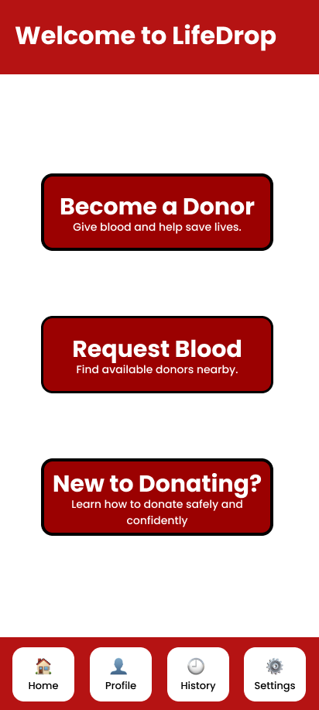

Fig 4.1: Home screen with options to Donate, Request, and view Guidelines.

**4.2 SCALABILITY AND FLEXIBILITY FOR HOSITALS**

The Online Blood Donation System enables seamless handling of blood requests through a structured and accessible interface. Users can submit request details such as blood group, urgency, and location, helping administrators or hospitals respond efficiently. The system is scalable and can accommodate a growing number of requests during critical periods. Figure 4.2 shows the Request Blood screen, where users initiate and track donation needs.

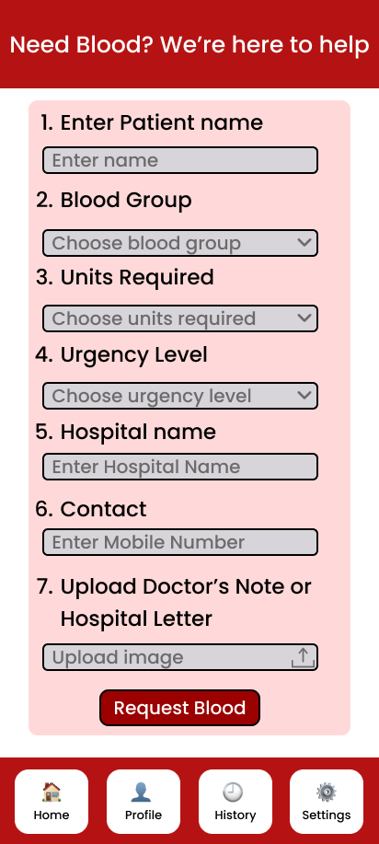

Figure 4.2: Request Blood screen where users can ask for blood in urgent situations.

**4.3 SECURITY CONSIDERATIONS**

Security is a key concern in the Online Blood Donation System, as it deals with personal user information, including contact details and medical needs. While the current version is a UI/UX prototype, future development should focus on secure login, encrypted data handling, and access control to ensure data privacy. These measures will help prevent unauthorized access and protect sensitive information. Fig 4.3 shows the Login screen, which provides the first level of security in the system.

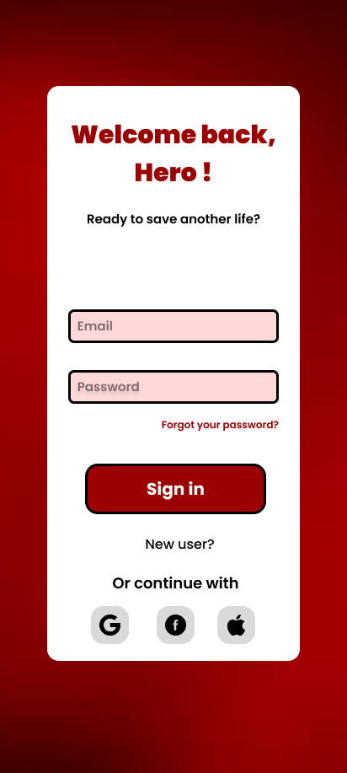

Fig 4.3: Login screen for secure user access to the system.

**4.4 OPERATIONAL EFFICIENCY AND COST REDUCTION**

The system enhances operational efficiency by reducing dependency on manual data collection, calls, and in-person coordination. Medical teams can access donor data, availability, and donation history instantly, enabling quicker response times. Features like automated reminders and donation tracking lighten the administrative workload, while also reducing costs related to paperwork, staffing, and communication. As a digital-first solution, the system supports eco-friendly practices and allows organizations to scale with minimal infrastructure overhead.

**4.5 CHALLENGES IN ADOPTION AND USABILITY**

While the Online Blood Donation System offers a user-friendly experience, there may still be challenges for individuals who are not familiar with digital platforms, particularly in areas with low digital literacy. First-time users may find it difficult to navigate certain sections or may hesitate to input personal health-related information. To address this, the system design focuses on simplicity, clarity, and mobile responsiveness, ensuring that users can access and understand the features with minimal effort. Providing tooltips, guided instructions, and multilingual support in future versions can further enhance accessibility and usability. Collecting user feedback regularly is also important to improve the overall experience based on real-world interactions. Fig 4.4 shows the user profile screen, which presents essential information like personal details and donation history in an organized and easy-to-read format.

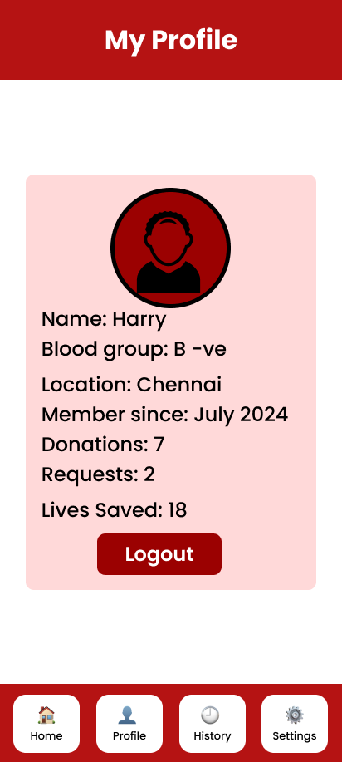

Fig 4.4: User profile screen showing donation history and personal details.

# CHAPTER 5

# CONCLUSION

The **Online Blood Donation System** effectively modernizes the process of finding, requesting, and donating blood through a convenient, intuitive platform. It empowers users—both donors and recipients—by enabling quick registration, seamless matching, and real-time tracking, thereby reducing delays and improving the efficiency of life-saving blood transfers.

For medical institutions and organizations, the system offers a centralized way to manage donor records, monitor donation activities, and organize campaigns. This helps in scaling outreach efforts, improving donor retention, and ensuring that critical requests are fulfilled promptly and accurately.

While the system provides several impactful features, it also highlights the importance of ongoing security enhancements, system maintenance, and responsiveness to user needs. Future improvements such as backend integration, mobile app support, AI-based donor-recipient matching, and multilingual accessibility can further elevate its utility and reach.

In conclusion, the **Online Blood Donation System** stands as a promising digital initiative aimed at fostering a more connected, efficient, and responsive ecosystem for blood donation—bringing life-saving support closer to those who need it, when they need it most.

# REFERENCES

1. World Health Organization, 2023. Blood Safety and Availability.
2. Dubey, A. and Jain, A., 2020. Design and Development of a Web-Based Blood Donation Management System. International Journal of Scientific Research in Engineering and Management (IJSREM), 4(2), pp.1–5.
3. Raza, S.A. and Rehman, M., 2019. Smart Blood Bank: A web-based application for efficient blood donation system. Procedia Computer Science, 164, pp.706–713.
4. Khan, F. and Beg, M.O., 2020. Mobile Application for Blood Donation and Blood Bank Management. International Journal of Computer Applications, 176(28), pp.32–36.
5. Bala, A. and Gupta, S., 2018. Online Blood Bank Management System. International Journal of Engineering Research & Technology (IJERT), 7(04), pp.561–564.
6. National AIDS Control Organization (NACO), 2022. Guidelines for Blood Banks and Blood Transfusion Services.
7. Agarwal, N. and Yadav, S., 2019. A Secure Online Blood Donation System Using Cryptography. International Journal of Advanced Research in Computer Science, 10(5), pp.50–54.
8. Patel, M. and Shah, R., 2021. A Review on Blood Donation Mobile Applications and Their Impact. International Journal of Computer Sciences and Engineering, 9(6), pp.15–20.
9. Verma, S. and Singh, P., 2020. Role of ICT in Health Care: Blood Donation Awareness and Mobile Apps. International Journal of Scientific and Technology Research, 9(4), pp.456–460.

**APPENDIX**

**A. SCREENSHOTS**

 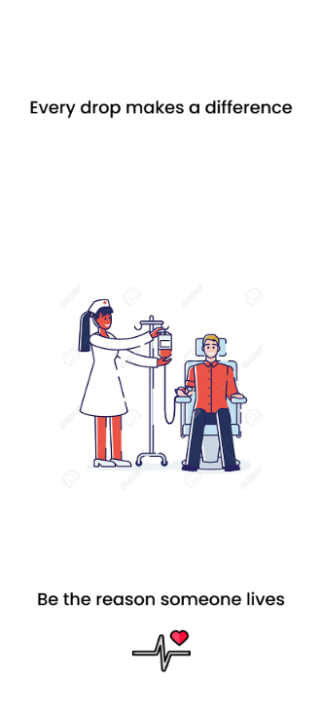

Fig a: Splash screen and Onboarding screen

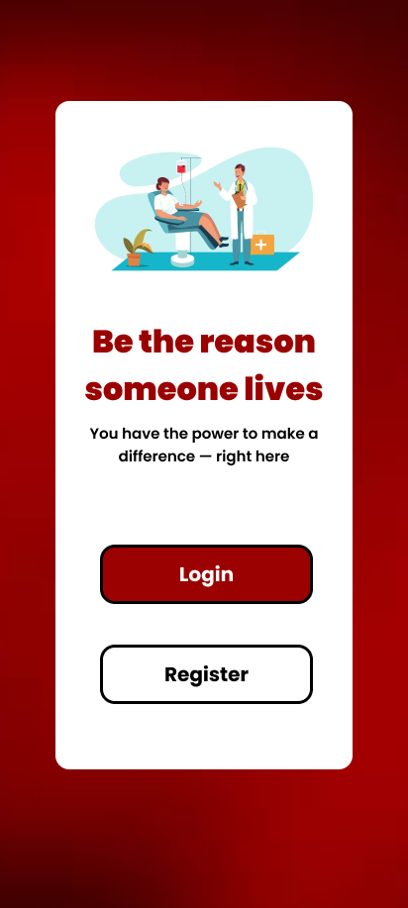 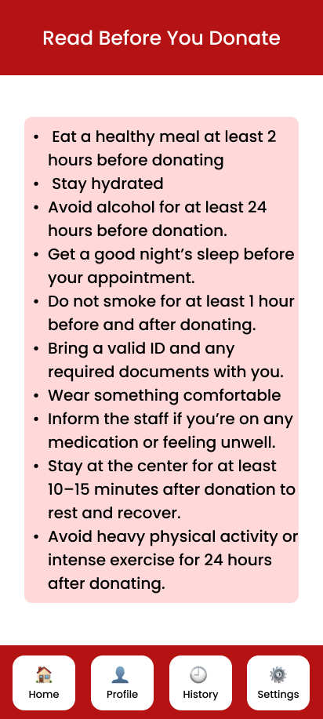

Fig b: Sign up screen and Guidelines screen

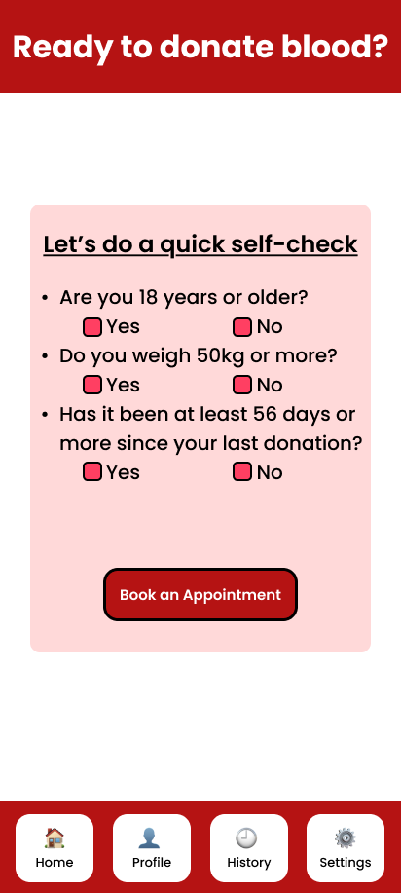 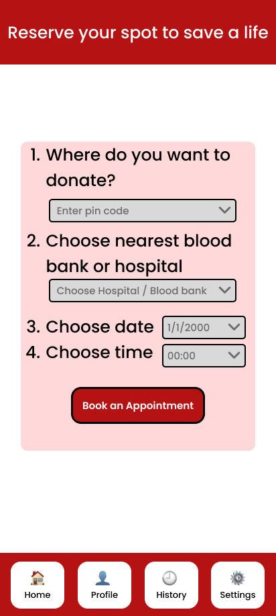

Fig c: Donate Blood Screen

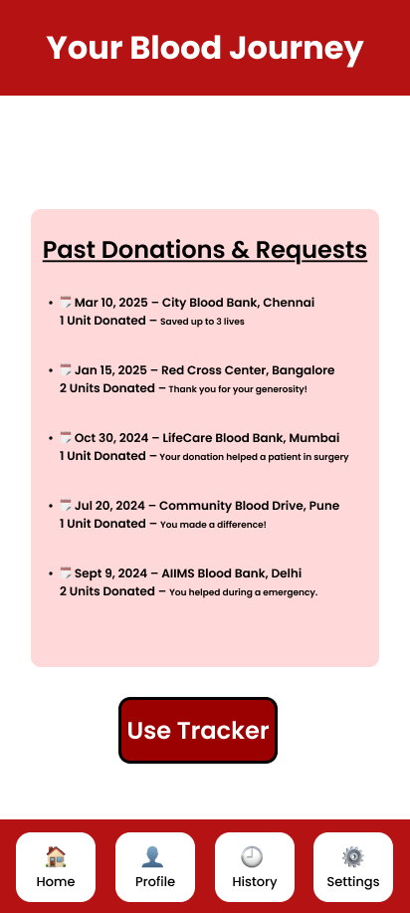 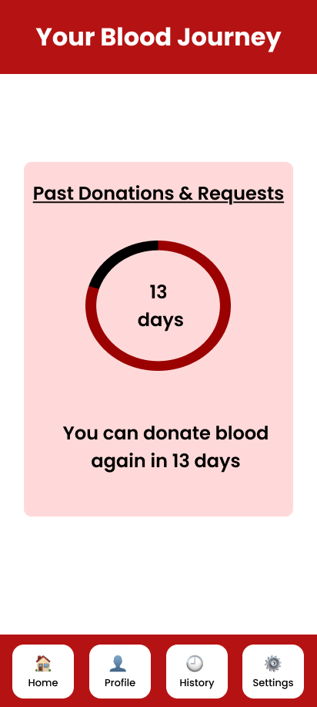

Fig d: History screen and Tracker Screen